“Ask me what helps me and do something about it.”
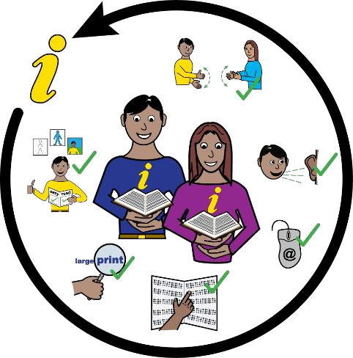
This is a summary of a report about getting information you can understand from doctors, hospitals, dentists and social workers.

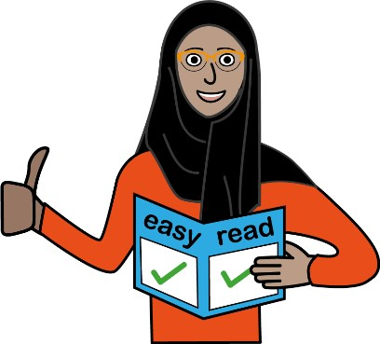
In 2016 a new law (the Accessible Information Standard) said all health and care organisations must give people information they can understand. This means information from doctors, hospitals, dentists and social workers should be in Easy Read if you want that.
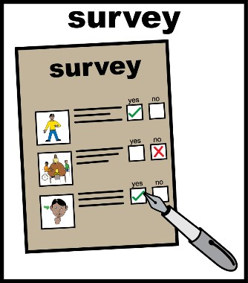
Healthwatch North Yorkshire and Healthwatch York asked lots of people if they get information in the format they want.
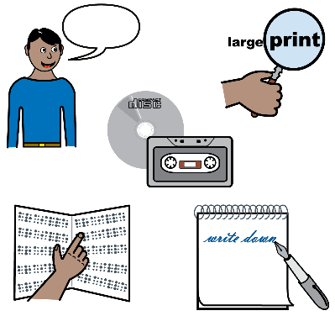

North Yorkshire County Council helped us talk to lots of groups. It is also doing work to make sure it always gives information to people in the format they want.

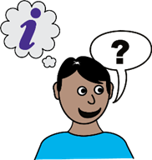
The people we asked told us if they get information in a format they can read. Some said yes. Lots of people said no. Most people said no one had asked them what format they want information in.
x

What people told us:

I want to do things myself (be independent)
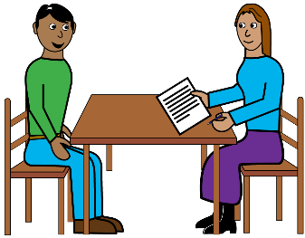
Many people had to ask other people when they did not get information in the format they want. This meant they could not do things on their own.
Lots of organisations sent information in a standard letter. The letters had a phone number if you want to ask questions.
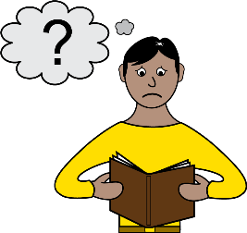
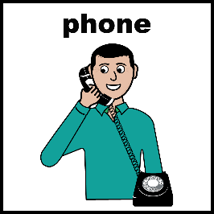
But some people can’t read these letters. People who are deaf, cannot talk or have other problems, can’t use the phone.
- x

These people have to ask someone else to help.

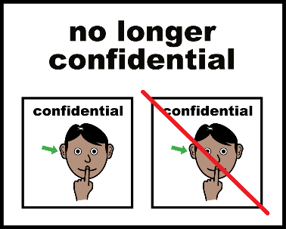
So someone else sees private information about them. This is not good.

Not getting information I can read makes me feel: frustrated, sad and angry
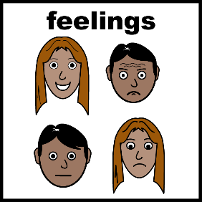
We asked people how they feel when they don’t get information in a format they can understand.
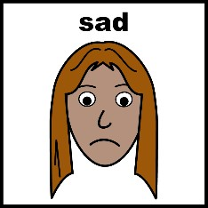
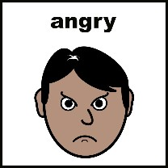
Most people said they are frustrated, sad, angry and annoyed.
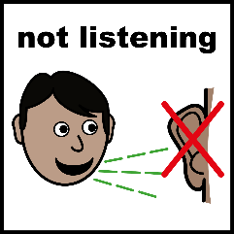

Some people said they felt ignored.

Some people said they don’t expect to get information they can read.

What people said shows organisations why they must send information so people can understand it themselves.

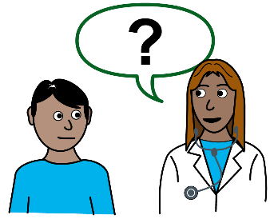
Listen and do something
Organisations must ask people how they want to get information, listen and then do something. Eg do they want Easy Read, texts, emails, large print or other formats?
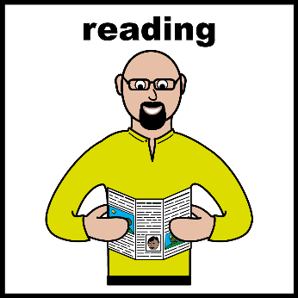
Lots of the organisations we asked said they do ask people and write their needs down. But people told us that they still don’t always get information in the right format.
x
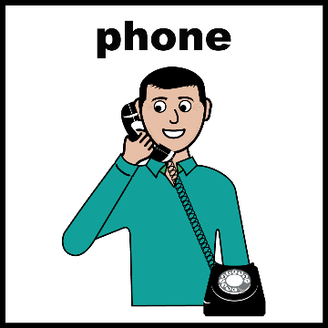
Eg, people asked the doctor not to phone them because they can’t use the phone. The doctor put this on the person’s notes. But the doctor still rings them on the phone or tells them to phone the doctor.
x
x
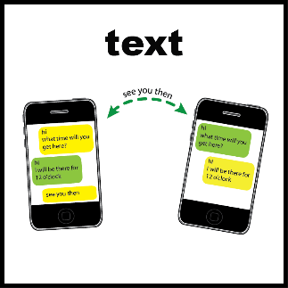
Some people told the doctor not to text them as they can’t read texts. But the doctor still sends text messages. They can’t read the messages and sometimes miss appointments.
People told us that no one should guess what they need. Not everyone with the same health problem wants information in the same way. Eg not everyone with a learning disability wants Easy Read letters. Some people would like emails or texts. Also, not everyone can use computers.

Doctors should ask everyone how they want information.

It’s not just sending information, it’s about everything
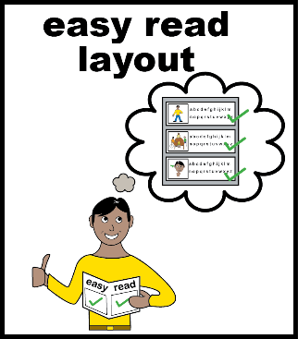
The words in a letter are important. You can’t just add images to make it Easy Read. The words need to be in Plain English and easy to understand. That is good for everyone.

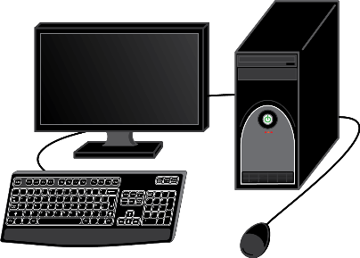
Computers can read documents to people. But they can’t read pdf documents. These are documents saved in a certain way. So information must be sent in a way people or computers can read. Any pictures or charts must be explained.

When you go to an appointment your needs must be met. This means that nurses, doctors and other staff must:
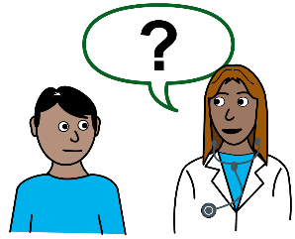
- Talk to someone if they cannot read information saying when it is their turn.
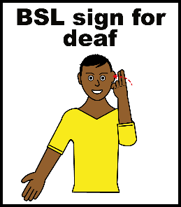
- Make sure someone knows it is their turn if they cannot hear.
- Provide a BSL (British Sign Language) interpreter if someone needs it.
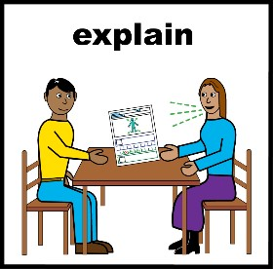
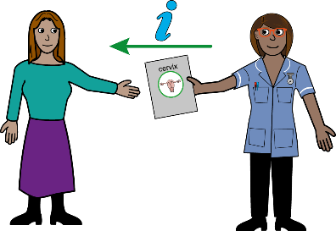
- Give people information and leaflets in Easy Read if they need it.
- Talk to people and make sure they understand the information about their health or care.

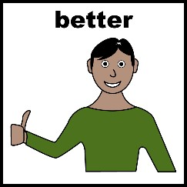
Learning from good examples
We found some good examples. One quarter of the people we heard from said things had got better in the last 6 years and they now get more things in the right format.

Organisations that are doing good things must help others. Organisations must also make sure everyone in the organisation is giving people information that they can understand.
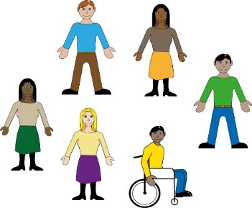
Get experts involved to find solutions
Lots of people who need information in a different format can help organisations do better.

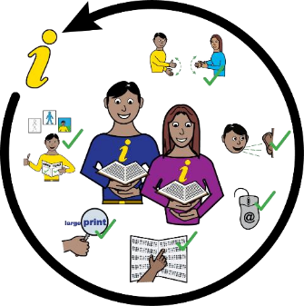
These people know what they need and can help organisations help other people. Organisations must listen to people who know about accessible information. They must get them involved in doing things better.

What organisations should do
What people told us helped up make a list of things organisations need to do. If they do this, it means people will get information they can understand without help.

We want organisations to:

- Ask what helps and do something about it.

- Make sure everyone in the organisation knows that giving information people can understand is important and should be done. Key staff must make sure this happens.
✓
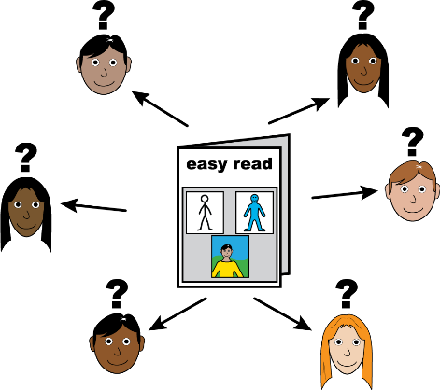

- Ask people how they want to get information. Write this down and always send information in the way someone wants.

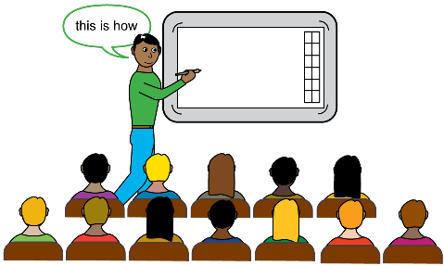
- Make sure everyone in the organisation knows how someone wants to get their information. So every time something is sent it is in a way a person can understand it.

- Ask people who need information in different ways to help.

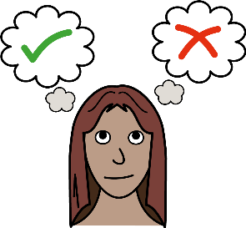
- Give choice. Don’t think you know what kind of information people need. Ask first.

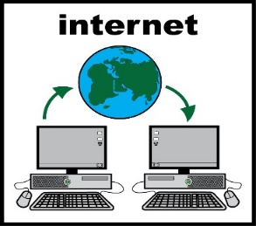
- Remember not everyone can use a computer.
x

- Have one person or one team to help people get information in a way they can understand. This means a person only has to ask once to get the help they need.
- Share what works. Learn from other organisations and tell other people when you do something good. Keep trying to be better.

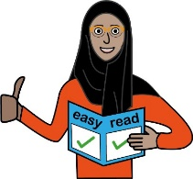
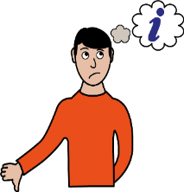
- Check that you are doing the right thing. Ask people if they are happy. Learn from what they say and make things even better.

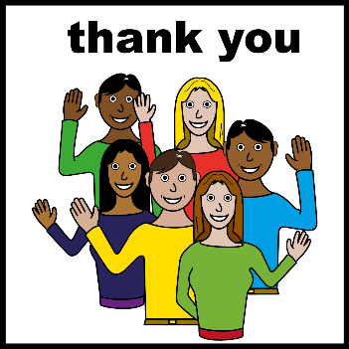
Thank you to everyone who filled in our survey and told us what happens to them.

Special thanks to North Yorkshire County Council, Key Ring, Leeds Society for Deaf and Blind People, MySight York, Sight Support Ryedale, The Wilf Ward Family Trust Jigsaw group, Vision Support Harrogate District and Yorkshire Coast Sight Support.

